Junit Basic Testing Exercises

# Exercise 01 – Setting Up Junit

pom.xml

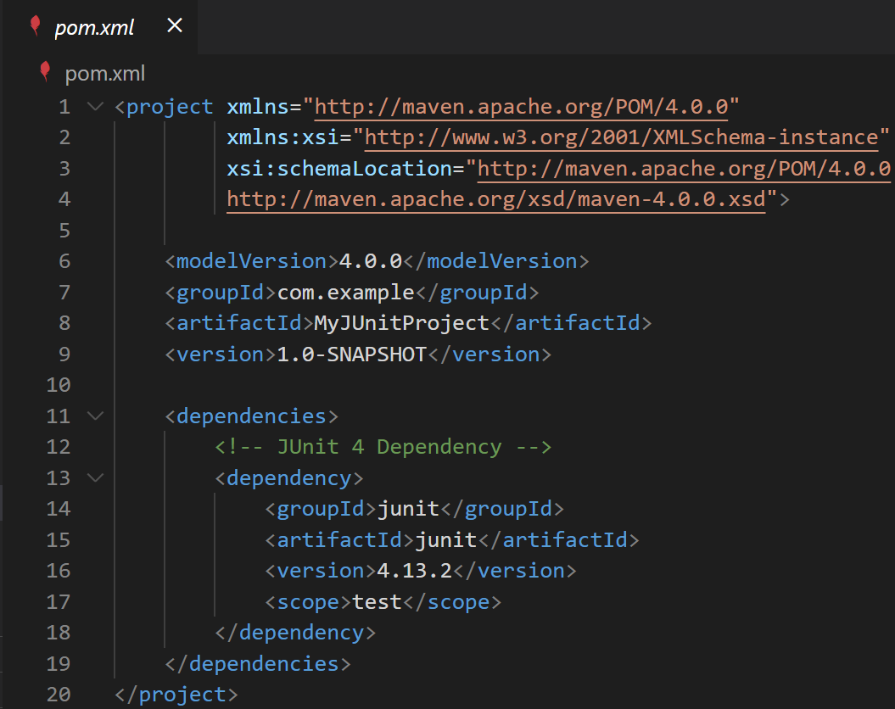

Calculator.java (src\main\java\com\example)

CalculatorTest.java (src\test\java\com\example)

Output: (In new Terminal)

Output: (Run the @Test)

# Exercise 03 – Assertions in Junit

pom.xml

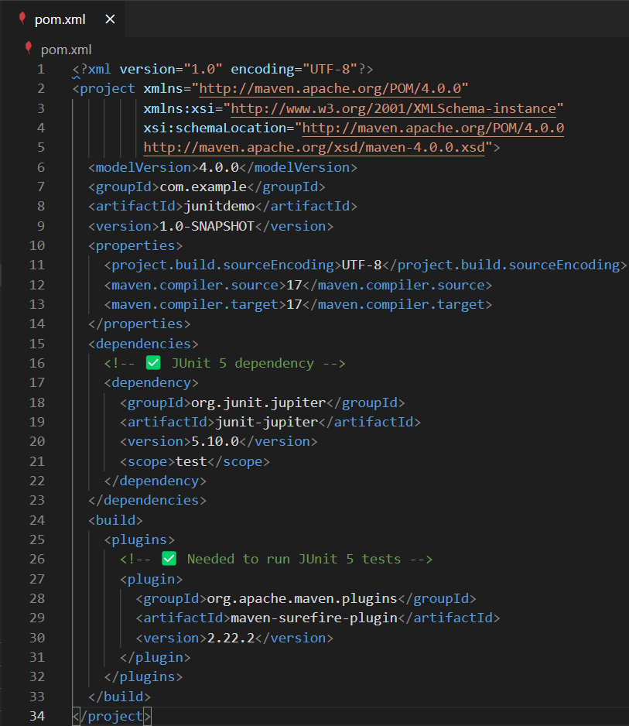

Assertions.java (src\main\java\com\example)

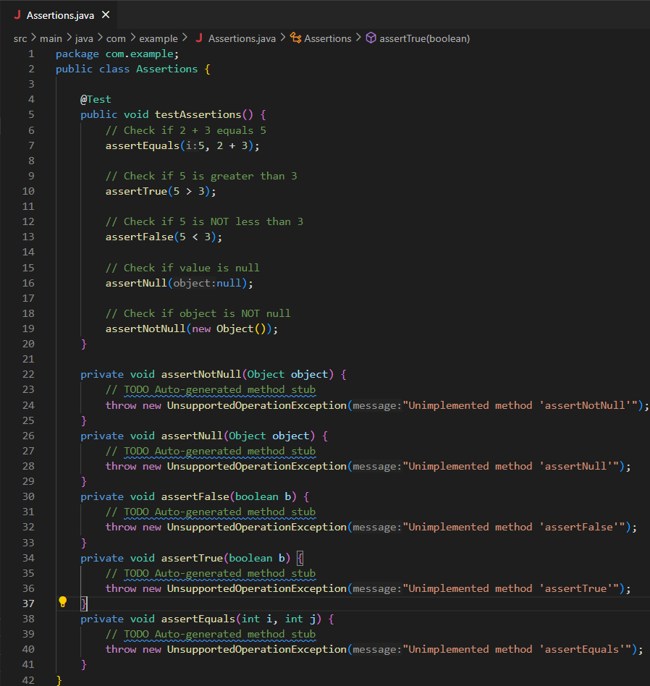

AssertionsTest.java (src\test\java\com\example)

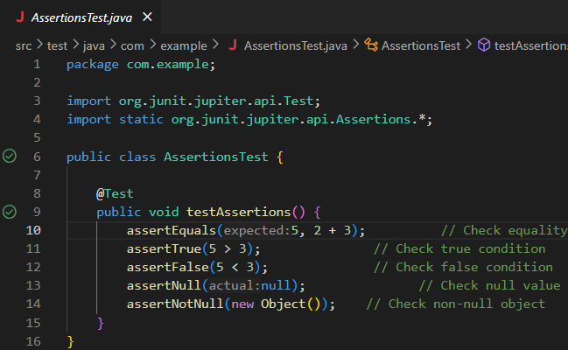

Output: (In new Terminal)

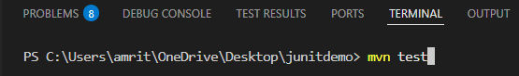

Output: (Run the @Test)

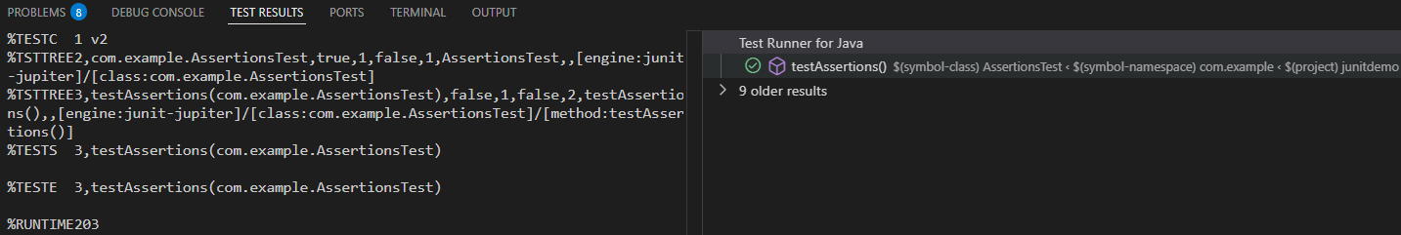

# Exercise 04 – Arrange-Act-Assert (AAA) Pattern, Test Fixtures, Setup and Teardown Methods in Junit

pom.xml

Calculator.java (src\main\java\com\example)

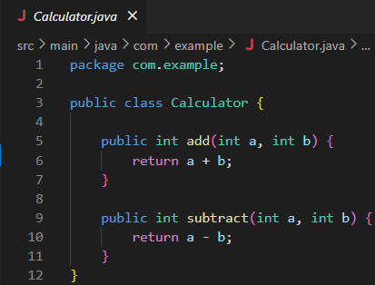

CalculatorTest.java (src\test\java\com\example)

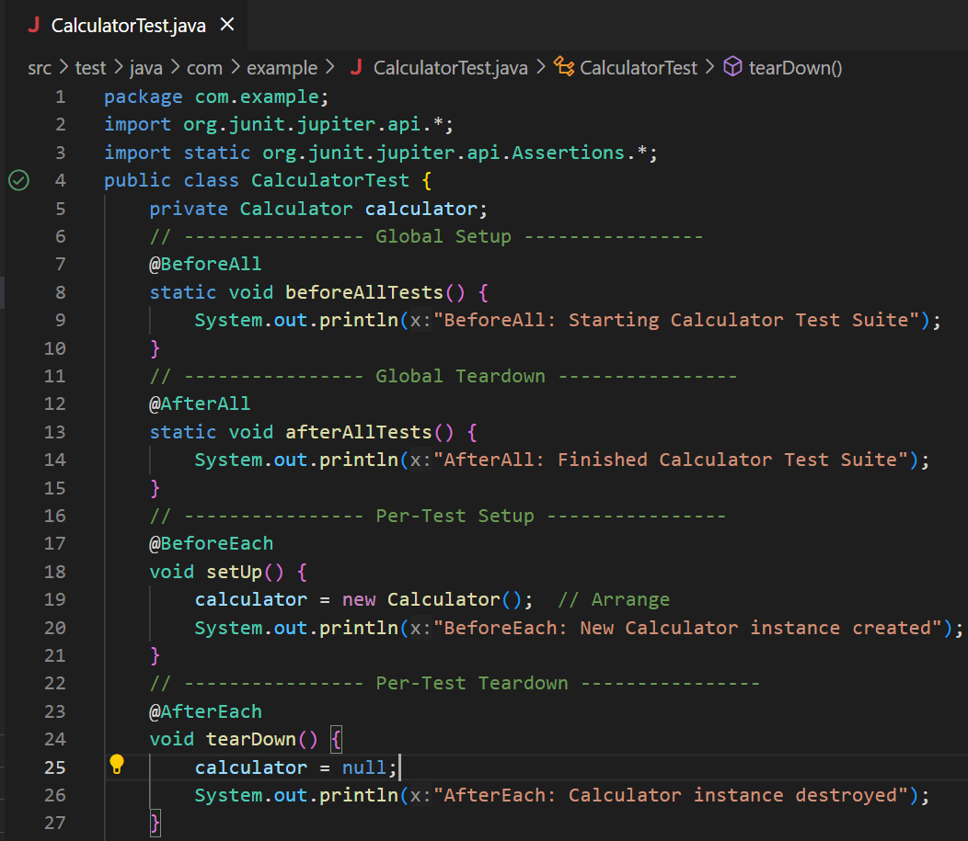

Output: (In new Terminal)

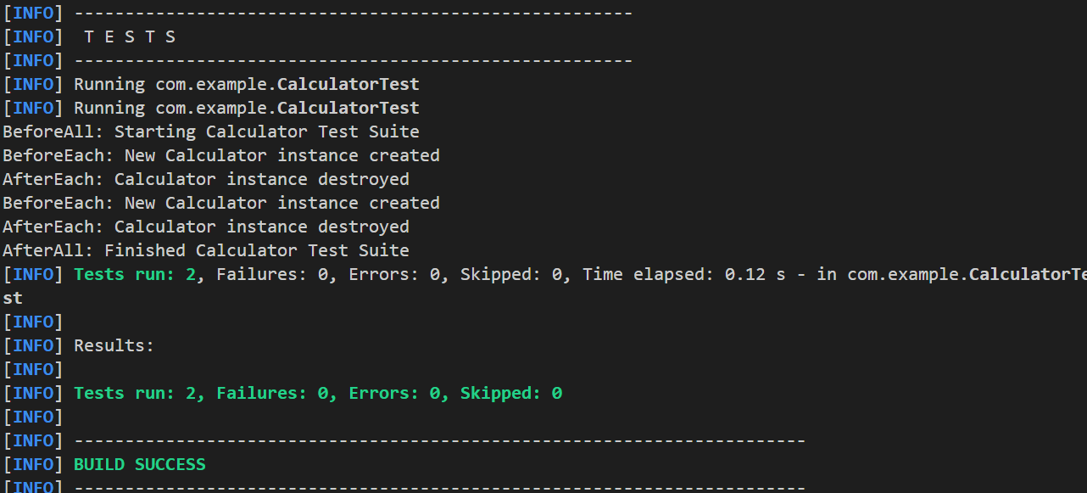

Output: (Run the @Test)

